
WILLITON PARISH COUNCIL

2 Killick Way, Williton, Somerset TA4 4PY
Tel: 01984 633979
Email: willitonpc@btconnect.com
www.willitonparishcouncil.org

Dear Councillor 8th July 2015
You are hereby summoned to attend a meeting of the Environment and Planning Committee of the Williton Parish Council to be held on Monday 13th July 2015, at 7.15pm at the Parish Office, Williton for the purpose of transacting the following business. If there are no items from the public the meeting will commence at 7pm. PLEASE ARRIVE 15 MINUTES EARLIER TO LOOK AT THE PLANS.

Members of the press and public are invited to address the Council 15 minutes prior to the commencement of the meeting at approximately 7.00pm, providing the notice period has been complied with. Please see Public Participation Notice.
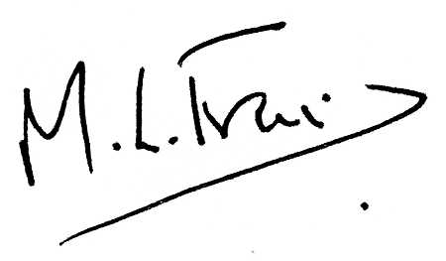

Yours sincerely
Michelle Francis
Clerk to the Council

Before the meeting a presentation will be made from David Peake, Highway Service Manager.

A G E N D A
15/19B |  | To note apologies for absence and approve reason, where appropriate
15/20B |  | Declarations of Interest
15/21B |  | Minutes of the Environment and Planning Committee meeting held on 8th June 2015 for approval  (sent with Full Council papers)
15/22B |  | Matters to Report from the Minutes
15/22.1B |  | (Item 15/06.1B) Pedestrian Routes
15/22.2B |  | (Item 15/06.2B) State of road at St Peter’s Close – update
15/22.3B |  | (Item 15/06.3B) Village Information Board
15/22.4B |  | (Item 15/06.4B) Flooding Matters
15/22.5B |  | (Item 15/06.5B) Owl Boxes in village - update
15/22.6B |  | (Item 15/06.6B) Doniford Footpath – see attached
15/22.7B |  | (Item 15/06.7B) Clean-up Day (Fence at Union Lane)
15/23B |  | Correspondence
15/23.1B |  | SWP June 2015 briefing – forwarded 15/6/15
15/24B |  | Highways Matters
15/24.1B |  | Footpath between Townsend and Catwell
15/24.2B |  | Townsend Road
15/24.3B |  | Haven Signs
15/24.4B |  | Sea Lane – speed restriction signs
15/24.5B |  | Coastal Path (Sea Lane) Warning Signs
15/25B |  | Finance and Budget
15/26B |  | Items of Report from Grounds Maintenance Officers
15/26.1B |  | Bridge Green (The Copse)
15/26.2B |  | Bellamy’s Corner
15/26.3B |  | Doniford Car Park
15/26.4B |  | Recreation Ground and Play Area
15/26.5B |  | Street Furniture
15/26.6B |  | Grass Verges
15/27B |  | Top 5 Parish Priorities – forwarded 08/07/15
15/28B |  | Waste Bin at Doniford Bus Shelter
15/29B |  | Garden of Rest
15/30B |  | To consider the following planning applications
Application No | Location | Description
3/39/15/009 | Shells Cottage, Shells Lane, Washford | Erection of three holiday units (resubmission of 3/39/14/025)
3/39/15/008 | 94 Long Street | Erection of a rear kitchen extension and conversion of the existing loft into habitable accommodation

 | 15/31B | To note the following planning decision
Application No | Location | Outcome
3/39/15/007 | 7A Long Street | Granted
3/39/15/005 | St Peters Church Rooms and ATC Hut, Priest Street | Granted
3/39/15/006 | 25 Doniford Road | Granted

 | 15/32B | Matters for the next meeting to be held on Monday 14th September 2015

